Summary of Recommendations

Legal interventions in Africa

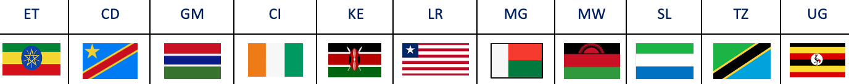

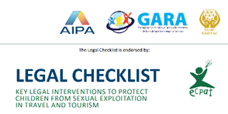
Background:
ECPAT International developed a legal checklist for governments providing guidance for legal interventions and measures to adopt in order to improve their national legal and policy frameworks. This helps to effectively address the crimes of sexual exploitation of children in travel and tourism, including its online elements.

The legal checklist was developed based on the recommendation of the first Global Study on sexual exploitation of children in the context of travel and tourism. Since the development of this legal checklist, ECPAT International has been conducting country legal analysis, currently available for over forty countries in Africa, South Asia, Southeast Asia and the Americas.

In Africa, the country analysis is available for Ethiopia, the Democratic Republic of Congo, the Gambia, Ivory Coast, Kenya, Liberia, Madagascar, Malawi, Sierra Leone, Tanzania, and Uganda. The country analysis serves as a baseline to indicate and track the implementation status of the legal interventions within and across regions. It provides governments with clear directions for improving their actions with respect to child protection against sexual exploitation in the context of travel and tourism and online.
ECPAT network is monitoring the actions taken by countries around the world towards ending the sexual exploitation of children. For this, Global Progress Indicators were also defined, with measurable aspects of national responses towards protecting children. The country analysis and the Global Progress Indicators provide practical guidance - when movement have been seen in a country the assessments are updated to highlight country progress.

The table below provides a summary of recommendations for Africa. It allows easy assessment of existing legislation and policies in the region against the 24 measures of the legal checklist.
An Assessment Matrix explains how to measure evidence of national legislative and policy responses and explains concrete steps needed for states to meet the action described in the 24 checklist points.

Table for visualisation:
Findings reflecting the 24-points of the legal checklist:
Yes | The matter has been regulated
Pa | The matter has not been regulated, however, other legal provisions could apply
No | The matter has not been regulated
? | Insufficient data

 | ET | CD | GM | CI | KE | LR | MG | MW | SL | TZ | UG
 | 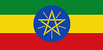 | 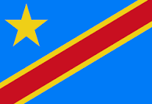 | 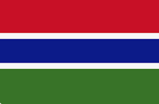 |  | 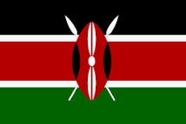 | 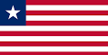 | 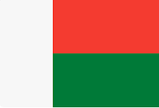 | 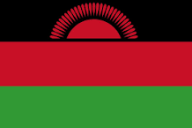 |  | 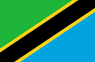 | 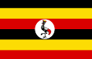
1 | Pa | Pa | Pa | Yes | Pa | Pa | Pa | Pa | No | Pa | Yes
2 | Pa | Pa | Yes | Pa | Pa | No | Yes | No | Pa | Pa | No
3 | No | Pa | Pa | No | No | Pa | Pa | Pa | Pa | No | Yes
4 | No | No | Yes | No | Yes | No | No | Yes | Yes | Yes | Yes
5 | No | Yes | No | Yes | Pa | Pa | No | No | No | Pa | Pa
6 | Yes | Yes | Yes | Yes | Yes | Yes | Yes | No | Pa | Yes | Yes
7 | Pa | Pa | Pa | No | No | Pa | No | No | Pa | No | Pa
8 | No | No | No | No | Yes | No | No | No | No | No | No
9 | Pa | Yes | No | No | No | Yes | Yes | No | No | Pa | Yes
10 | Yes | Yes | Yes | Pa | Yes | Yes | Yes | Yes | Yes | Pa | Yes
11 | Pa | No | No | Pa | No | Yes | Yes | No | No | No | No
12 | No | Yes | No | No | No | Yes | Yes | Pa | Yes | Yes | Yes
13 | No | No | Yes | No | No | No | Pa | No | No | No | No
14 | No | Pa | Yes | No | Yes | No | No | No | Pa | Yes | Pa
15 | Pa | No | No | No | No | No | Yes | No | No | No | No
16 | No | No | No | No | No | No | No | No | No | No | No
17 | No | No | No | No | No | No | No | No | No | No | No
18 | Pa | Pa | Pa | Pa | No | No | Pa | Pa | Pa | Pa | No
19 | No | Yes | Yes | No | Yes | No | No | No | No | Pa | Pa
20 | No | Pa | Pa | No | No | No | Pa | Pa | Pa | Pa | Pa
21 | Pa | Yes | Yes | Pa | Yes | No | No | No | Yes | No | Pa
22 | Pa | Yes | Pa | Yes | Yes | Pa | Yes | Yes | Pa | Yes | Yes
23 | Yes | No | No | Yes | No | No | No | Yes | No | Yes | No
24 | Yes | Yes | Yes | Yes | Yes | No | Yes | Yes | Yes | Yes | Yes

Africa regional overview:

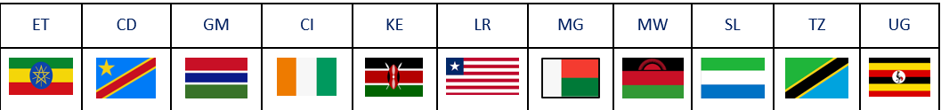
Measure 1: Establish by law extra-territorial jurisdiction, within the parameters of Article 4 OPSC, for all offences of sexual exploitation of children, including those occurring in the online environment.
Indicator: The country has appropriate extraterritoriality provisions for sexual exploitation of
children crimes.

Out of the 11 countries, only Sierra Leone does not establish by law at all extra-territorial jurisdiction within the parameters of Article 4 OPSC. All the other countries have provisions on extraterritorial jurisdiction for some offences of sexual exploitation of children. Ivory Coast and Uganda have regulated the matter fully. Kenya, Malawi, and Tanzania include provisions on extraterritorial jurisdiction for SEC-related offences occurring in the online environment. However, most of the countries fail to include passive extraterritorial jurisdiction (i.e., extraterritorial jurisdiction based on the nationality of the victim).

Measure 2: Include in extradition treaties the sexual exploitation of children as extraditable offences and apply when appropriate the rules of article 5 OPSC, regardless the nationality of the (alleged) offender.
Indicator: The country has appropriate extradition provisions for sexual exploitation of children crimes.

Out of the 11 countries, only Gambia and Madagascar include in their law the sexual exploitation of children as extraditable offences. Ethiopia and Ivory Coast prohibit the extradition of nationals.
Malawi, Liberia, and Uganda do not include the sexual exploitation of children as an extraditable offence. All the others include only some SEC-related offences as extraditable offences.

Measure 3: Do NOT require the principle of double criminality for proceeding with extraterritorial jurisdiction or extradition for sexual offences against children.
Indicator: The country has appropriate extraterritoriality and extradition provisions for sexual exploitation of children crimes.

Out of the 11 countries, Uganda is the only country which doesn't apply the principle of double criminality in both cases. Six countries only apply the principle of double criminality for either extradition or extraterritorial jurisdiction. Ethiopia, Ivory Coast, Kenya and Tanzania apply the principle of double criminality for sexual offences against children both for extraterritorial jurisdiction and extradition.

Measure 4: Abolish statutory limitations for the prosecution of offences of sexual exploitation of children.
Indicator: Statutory limitations do not apply for all offences of sexual exploitation of children.

Out of the 11 countries, the Gambia, Kenya, Malawi, Sierra Leone, Tanzania, and Uganda abolished the statutory limitations for the prosecution of offences of sexual exploitation of children. Ethiopia, the Democratic Republic of Congo, Ivory Coast, Liberia, and Madagascar didn't abolish statutory limitations at all.

Measure 5: Set up conditions for any travel by persons convicted of sexual exploitation of children. Indicator: The country has set up conditions for the travel of persons (both nationals and foreigners) convicted of sexual exploitation of children.

Out of the 11 countries, only Ivory Coast prohibits to enter and to leave, or only under strict conditions, the territory for any person convicted of the sexual exploitation of children. Kenya, Liberia, Tanzania, and Uganda include provisions specific enough to deny the entry of foreigners convicted of sexual exploitation of children but don’t include provisions to ensure the prohibition of persons convicted of sexual exploitation of children to leave the country. Ethiopia, the Democratic Republic of Congo, the Gambia, Madagascar, Malawi, and Sierra Leone don’t include provisions specific enough to deny the entry nor the leave of foreigners convicted of sexual exploitation of children.

Measure 6: Ensure consistency in the definition of a ‘child’ as anyone under the age of 18 for all crimes of sexual exploitation, regardless of the age of sexual consent.
Indicator: The national legislation consistently defines a child as anyone under the age of 18 for all crimes of sexual exploitation.
Out of the 11 countries, nine countries define ‘child’ for the purposes of sexual exploitation as anyone under the age of 18. National laws in Malawi and Sierra Leone do not consistently define ‘child’ as anyone under eighteen years old and include other definitions of ‘child’ including as anyone under the age of sixteen or fourteen years old.

Measure 7: Ensure that the age of sexual consent for both males and females is 18 and a close in age exemption (up to 3 years) is provided for consensual sexual relationships between adolescents in order to allow voluntary, well-informed and mutual sexual contact between close in age peers and to prevent criminalization of young people in willing sexual relationships.
Indicator: The age of sexual consent for both males and females is 18 and a close in age exemption (up to 3 years) is provided for consensual sexual relationships between adolescents.

Out of the 11 countries, Ivory Coast, Kenya, Madagascar, Malawi, and Tanzania don’t provide any criteria within their national legislation. All the others partially implement provisions establishing a close-in-age exemption.

Measure 8: Have a law or regulation establishing a mechanism for centrally registering sex offenders that has been implemented/setup.
Indicator: The national legislation establishes a national mechanism for centrally registering sex offenders that has been implemented/setup.

Out of the 11 analysed countries, only Kenya implements a child sex offenders' registry. Other analysed countries don't have a sex offenders' registry even though Uganda established a register of pornography offenders.

Measure 9: Establish bail conditions that prohibit individual accused of sexual offences against children from traveling outside of the country.
Indicator: The national legislation establishes bail conditions that prohibit individuals accused of sexual offences against children from travelling outside of the country.

Out of the 11 countries, the Democratic Republic of Congo, Liberia, Madagascar, and Uganda established bail conditions for all SEC offences. Ethiopia, and Tanzania considers only some of the SEC-related offences as non-bailable offences. All the others do not have a bail system that prohibits individual accused of offences of sexual exploitation of children from travelling outside of the country.

Measure 10: Provide in law that the mere attempt to commit a crime of sexual exploitation of children is criminalised.
Indicator: The national legislation specifically criminalises attempted sexual exploitation of children related offences.

Out of the 11 countries, nine countries provide in law that the mere attempt to commit a crime of sexual exploitation of children is criminalised. Ivory Coast and Tanzania partially comply with the measure.

Measure 11: Impose more severe sentences for reoffending in case of sexual exploitation against children, e.g. by defining reoffending as an aggravating circumstance, regardless of whether the crimes were perpetrated abroad or in-country.
Indicator: The national legislation provides for more severe penalties for reoffending in case of sexual offences against children.

Out of the 11 countries, only Liberia and Madagascar impose sentences more severe in cases of recidivism. Ethiopia and Ivory Coast apply more severe sentences in cases of recidivism but also include a five-years limitation period, which can be barrier.

Measure 12: Provide for mandatory reporting for particular professions that have likelihood to have contact with children who might disclose sexual exploitation.
Indictor: The national legislation provides for mandatory reporting for particular professions that have likelihood to have contact with kids who might disclose.
Out of the 11 countries, the Democratic Republic of Congo, Liberia, Madagascar, Sierra Leone, Tanzania and Uganda Provide for mandatory reporting for professions that have likelihood to have contact with children who might disclose sexual exploitation. Malawi only partially regulates the matter while the remaining countries do not provide any mandatory reporting in their legislation.

Measure 13: Establish obligatory government-regulated child protection standards for the tourism industry for example, attach responsibility to an appropriate regulatory authority and/or implement industry specific national codes for child protection as a legal requirement for the travel and tourism industry to operate.
Indicator: Child protection standards for the travel and tourism industry exist.

Out of the 11 countries, only the Gambia adopted an obligatory national code of conduct for the protection of children and adolescents in travel and tourism. Madagascar adopted a national code of conduct that has been implemented in twelve regions. Other countries have neither established nor started the process.

Measure 14: Ensure the liability of travel and tourism businesses (in operations and supply chains) for criminal conduct including:
- Organising travel arrangements or transportation that are explicitly or implicitly meant to create or facilitate opportunities to engage (involve) children in sexual activities;
- Procuring, aiding or abetting the exploitative sexual conduct with a child;
- Advertising or promoting sexual exploitation of children;
- Benefitting, by any means, from any form of sexual exploitation of a child (or children) in the context of their travel and tourism business.
Indicator: The national legislation includes provisions to ensure the liability of travel and tourism businesses for sexual exploitation of children related crimes.

Out of the 11 countries, only the Gambia, Kenya and Tanzania fully ensure the liability of the private travel and tourism sector for SECTT. Cote d’Ivoire meets this requirement partially. Sierra Leone and Uganda implement few provisions but not specifically targeting the private travel and tourism sector. All the other countries don't ensure the liability of the private travel and tourism sector for sexual exploitation of children.

Measure 15: Criminalise the grooming of children for sexual purposes (often called ‘solicitation’ in law) including through Internet and other communication technologies to facilitate either online or offline sexual exploitation.
Indicator: The national legislation criminalises grooming of children for sexual purposes including through Internet and other communication technologies to facilitate either online or offline sexual exploitation.

Out of the 11 countries, only Madagascar criminalises the solicitation of children (‘grooming’) for sexual purposes including through the use of the Internet and other information and communication technologies. Ethiopia partially regulates the matter, while all the other countries don’t include any provisions on ‘grooming’ within their national legislation.

Measure 16: Establish legislation requiring for a criminal background check for every person (national or non- national) applying for work with or for children or who is currently working with or for children. Introduce legislation prohibiting convicted sex offenders to hold positions involving or facilitating contact with children.
Indicator: Criminal background checks are strict requirements for national and non-nationals working in direct contact with children.
None of the countries analysed adopt national provisions that require for a criminal background check for every person applying for work with or for children or who is currently working with or for children.

Measure 17: Regulate and monitor the use of volunteers (including in ‘voluntourism’) in settings and activities that involve direct contact with children, particularly prohibiting visits to orphanages/residential care settings in favour of redirecting the industry towards solutions that support community-based care.
Indicator: The national legislative and/or policy frameworks establish minimum standards for the context of voluntourism that include criminal background checks and prohibits visits to orphanage/residential care setting as tourism activities.
None of the countries under review establish minimum standards for voluntourism involving direct contact with children, such as criminal background checks or prohibition of visits to orphanage/residential care settings.

Measure 18: Ratify and implement relevant regional and international instruments related to child’s rights and sexual exploitation of children.
Indicator: The country has ratified all relevant regional and international instruments related to child’s rights and sexual exploitation of children.

The following international and regional legal instruments shall be ratified and implemented as they constitute comprehensive legal tools for protecting children from sexual abuse and exploitation:
- Convention on the Rights of the Child;
- Optional Protocol to the Convention on the Rights of the Child on the Sale of Children, Child Prostitution and Child Pornography;
- Optional Protocol to the Convention on the Rights of the Child on a Communications Procedure;
- Protocol to Prevent, Suppress and Punish Trafficking in Persons, especially Women and Children, supplementing the United Nations Convention against Transnational Organized Crime;
- International Labour Organizations’ s Convention concerning the Prohibition and Immediate Action for the Elimination of the Worst Forms of Child Labour No.182;
- African Union Charter on the Rights and Welfare of the Child;
- African Union Convention on Cyber Security and Personal Data Protection;
- Council of Europe Convention on Cybercrime (Budapest Convention);
- United Nations World Tourism Organization’s Framework Convention on Tourism Ethics (2019).
The country analysis shows that out of the 11 countries, only Ivory Coast ratified the Optional Protocol to the Convention on the Rights of the Child on a Communications Procedure.
Liberia and Kenya didn’t ratify the Optional Protocol to the Convention on the Rights of the Child on the Sale of Children, Child Prostitution and Child Pornography. Uganda is the only one that didn’t ratify the UN Protocol to Prevent, Suppress and Punish Trafficking in Persons, Especially Women and children while, while only the Democratic Republic of Congo didn’t ratify the African Union Charter on the Rights and Welfare of the Child. None of the countries ratify the African Union Convention on Cyber Security and Personal Data Protection, and the Council of Europe Convention on Cybercrime (Budapest Convention).

Measure 19: Establish protection measures for child victims at any stage of the legal process against the suspected offender.
Indicator: The national legislation establishes protection measures for child victims, enabling them to participate in the legal process.
Out of the 11 countries, only the Gambia, Kenya and Cote d’Ivoire establish protection measures for victims at any stage of the legal process against the suspected offender. Tanzania and Uganda only apply some protective measures, but these provisions are not sufficient to ensure full protection of child victims. All the other countries do not provide protection measures.

Measure 20: Establish child-friendly interviewing practices by professionally trained police.
Indicator: The national legislation requires that child victims are interviewed based on child-friendly interviewing practices and at least one Child Advocacy Centre exists in the country.

Out of the 11 countries, none fully implement this measure. Cote d’Ivoire, The Gambia, Madagascar, Malawi, Sierra Leone, Tanzania, and Uganda at different levels partially implement in law child-friendly interview methods, while all the other countries do not comply at all with the measure.

Measure 21: Ensure that national legislation provides the right for child victims to receive support in their recovery and rehabilitation, including accessing re-integration services.
Indicator: The national legislation stipulates that child victims can access support in their recovery and rehabilitation.

Out of the 11 countries, only the Democratic Republic of Congo, the Gambia, Kenya, and Sierra Leone provides the right for child victims to receive support in their recovery and rehabilitation, including accessing re-integration services. Ethiopia, Ivory Coast, and Uganda partially provide those services to children victims and often the services are not specific to child victims of sexual exploitation. Liberia, Madagascar, Malawi, and Tanzania don't have any support and re-integration services.

Measure 22: Establish a national reporting mechanism (e.g. hotline) that coordinates access to services, and helps to overcome reluctance to report sexual exploitation of children.
Indicator: A national reporting mechanism with response protocols that allow children and citizens to report without fear exist.

Out of the 11 countries, seven have developed systems for reporting SEC-related offences, although their effectiveness may be subject to a separate review, with limited public awareness about the reporting mechanisms, and underreporting of suspicious cases. Ethiopia, the Gambia, Liberia, and Sierra Leone, don’t have reporting systems specific to cases of sexual exploitation or abuse of children or don't include boys.

Measure 23: Create data retention and preservation laws, regulations and procedures, to ensure the retention and preservation of digital evidence and enable cooperation with law enforcement which applies to ISPs, mobile phone companies, digital social media and communication companies, cloud storage companies, based in/operating in national jurisdiction.
Indicator: The national legislation establishes retention and preservation laws and procedures that allow retention and preservation of digital evidence.

Out of 11 countries, only Ethiopia and Ivory Coast, Malawi and Tanzania implement such legislation and all the others don't implement any laws related to data retention and preservation.

Measure 24: Ensure that national legislation provides the right for all child victims of sexual exploitation to seek compensation in national courts from convicted perpetrators who harmed them and/or through state-managed funds.
Indicator: The national legislation provides the right for all child victims to seek compensation.

Out of 11 countries, all the countries except Liberia, have a mechanism to seek compensation.

Key recommendations for the Governments in Africa:

Obligatory government-regulated child protection standards
The regional analysis shows that out of the 11 countries, only the Gambia implemented an obligatory national code of conduct for the protection of children, to whom travel and tourism businesses are bound. Moreover, apart from Madagascar, all the other countries under analysis have neither established nor started the process of drafting and implementing a national code for the travel and tourism industry to protect children. In addition, only the Gambia, Kenya and Tanzania fully ensure the liability of the travel and tourism sector businesses for sexual exploitation of children related crimes.

As such, States in the region should:
- Establish obligatory government-regulated child protection standards for the tourism industry (i.e., adoption of specific national codes for child protection as a legal requirement for the travel and tourism industry to operate).
- Ensure the liability of the private sector for criminal conduct that occur both in the operation and supply chain.

Mandatory criminal background checks
The overview clearly shows that the region fails to prevent potential sexual (re)offenders to come directly into contact with children and adolescents. Indeed, none of the countries analysed requires mandatory criminal backgrounds for people working or volunteering for and with children. In addition, visits of orphanages and/or residential care settings as a form of tourism activities are still allowed.

As such, States in the region should:
- Amend their legislation with a view to establish mandatory criminal records checks for all people (national and not national) applying to work and/or volunteering for and with children;
- Prohibit by law visits to orphanage/residential care setting as tourism activities.

Grooming of Children for Sexual Purposes
The analysis demonstrates that the region clearly fails to criminalise the grooming (or “solicitation”) of children including via the use of digital technologies for sexual purposes. Indeed, only Madagascar has criminalised grooming of children while Ethiopia partially regulates the matter.

Governments in the region should:
- Criminalise the grooming of children for (online or offline) sexual purposes including through Internet and other communication technologies.
…………………………………………………………………………………………………
A global problem requires truly global solutions to address the sexual exploitation of children.
For the most updated information refer to the Global Progress Indicators, select an indicator to see global progress or click a country on the map for a national summary.
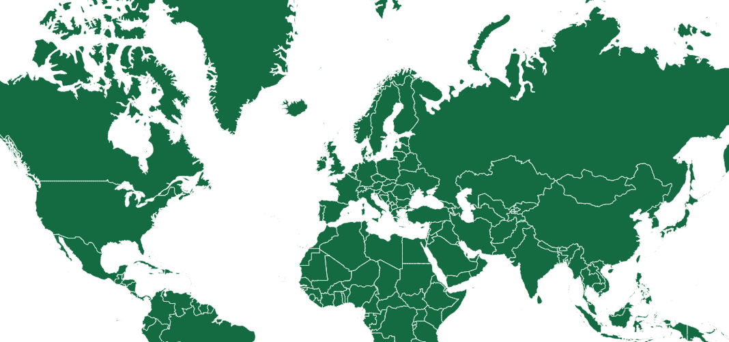
www.ecpat.org

